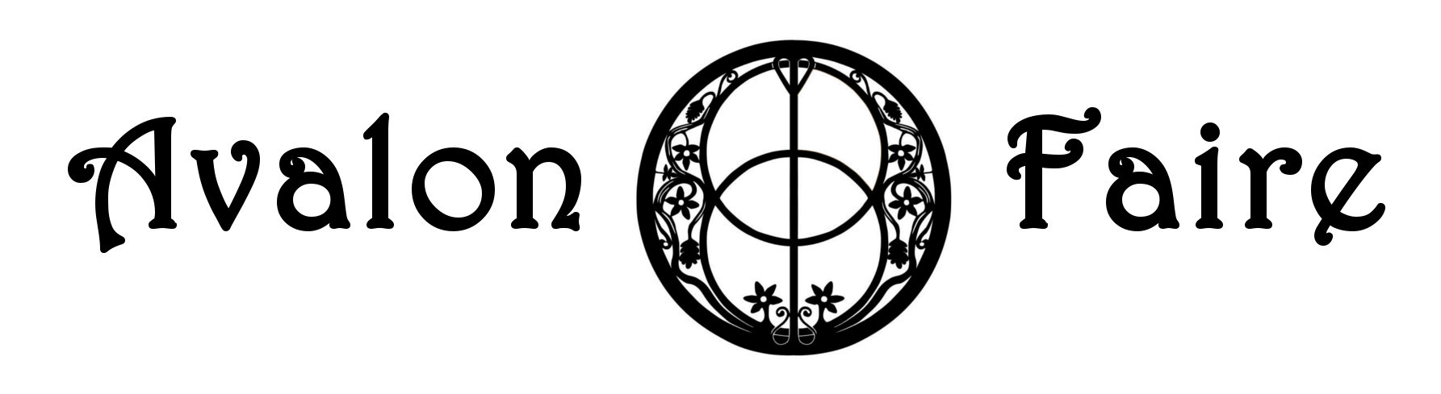
Vendor Agreement
Oktoberfest 2023 is Friday, October 6th, 6 pm – 9 pm and Saturday, October 7th Noon – 9 pm. You are required to be open on both days for the entire event, tear down will start after 9 pm on Saturday, October 7th. The fee is $35, this event has an Oktoberfest theme, however, you can use modern coverings such as an EZ up and sell any family-friendly item. Vendors must be set up by 5 pm on Friday and you cannot begin to tear down until the event is over. You are responsible for all your equipment and lighting, as well as cleaning up when you leave. You must provide a deposit of $50 at setup in the form of a check which will be returned once your space has been signed off by the Vendor Coordinator. All vendors must provide a valid Sales Tax ID number and proof of Insurance Coverage. The minimum amount of coverage will include and state in the Certificate of Liability and you need to list Avalon Faire LLC as co-insured:
General Aggregate Limit $300,000.00
Product-Completed Operations Aggregate $300,000.00
Each Occurrence $300,000.00
Fire Damage (any one fire) $50,000.00

CONTACT NAME_____________________________________ PHONE_________________________

BUSINESS NAME_____________________________________ SALES TAX ID____________________

WEBSITE________________________________ EMAIL___________________________________

ADDRESS________________________________ CITY/STATE/ZIP___________________________

Description of product or service: _________________________________________________________
____________________________________________________________________________________
____________________________________________________________________________________
____________________________________________________________________________________
____________________________________________________________________________________
Where did you hear about Avalon Faire? __________________________________________________

Avalon Faire is located at 1076 FM 1252W, Kilgore, TX 75662. Email your completed form to vendor@avalonfaire.com. Payments can be made through our website avalonfaire.com on the ticketing page. Form and payment are due no later than September 1, 2023. If you need more information, you can call Avalon at 903-985-7633. Camping is available for a separate fee.

